Lab 6

Model the Motion of Manipulator

Done by: Shamil Sarmonov

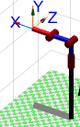

In this lab RRR model will be used. The goal of this lab is to reach the necessary position of the RRR robot by tuning the PID controller.

In this lab, simple proportional gains are applied in order to achieve the goals.

The initial parameters of the gain for RRR are simple: [1 1 1], however, because of the gravity, the joints do not achieve those angles that are needed.

That is why, some tuning was applied.

Figure 1. RRR Robot

The RRR should reach from [0 0 0] angles to [90 -45 -45] degrees angles.

First, parameter was first changed to 100, and the final position of the first angle was achieved. Next, it was more difficult to achieve the positions (angles) of the second two joints.

It was found that when the second parameter of the gain is increasing, second joint better achieve the goal, and when the third is increasing, third is achieving, so as big is the value, so well is the result.

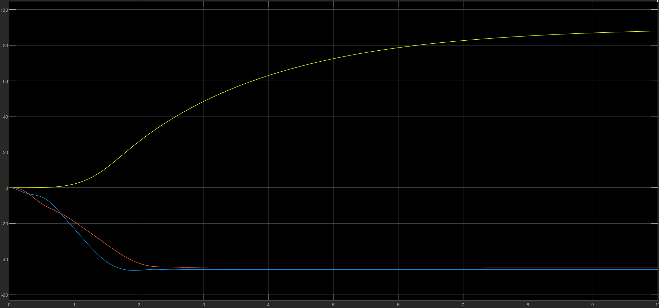

Figure 2. Gain parameters: [100 10000 200] \* 1

Although the values almost reached the required ones, however, it can be seen that there is some difference between 2nd and 3rd lines. In the next step it would be checked if the gain parameters are increased (Fig. 3).

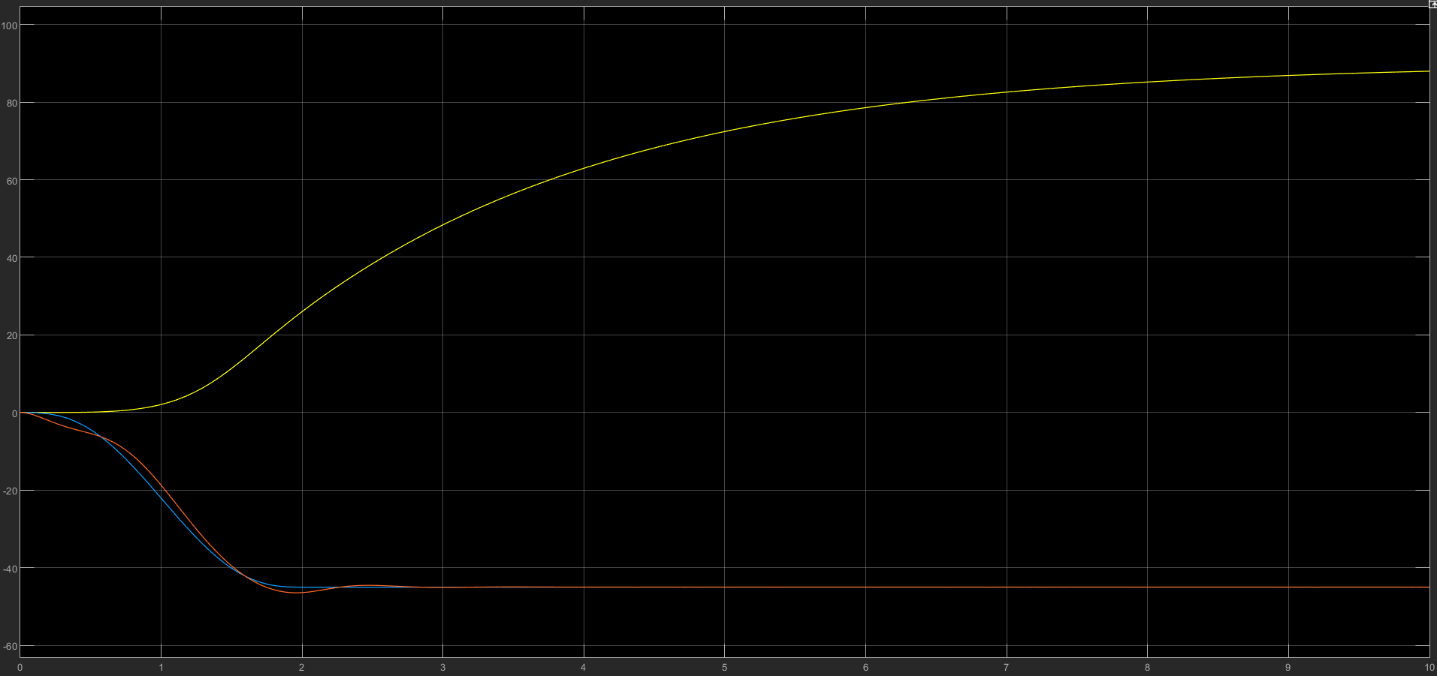

Figure . Gain parameters: [100 1000000 2000] \*1

It can be found that the second two angles are achieving the goal, reaching -45 degrees angle, although there are some fluctuations before.

To conclude, it can be found that in order to reach the required positions it is needed to increase the gain parameters. As the gain parameters are increasing the required position is better achieved. To conclude, according to the results the goals are achieved.